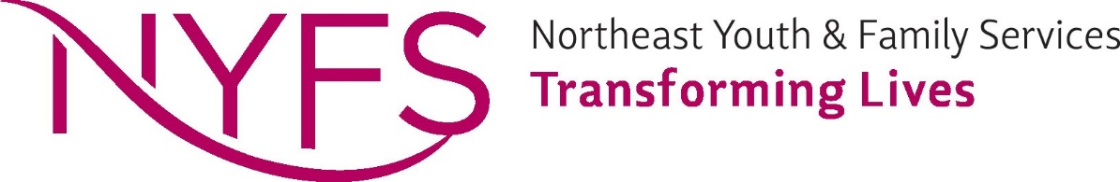
PERMISSION TO MAIL SATISFACTION SURVEY

Northeast Youth & Family Services is committed to developing and maintaining the highest qualities of service. Your input as to your experience with our agency is important to us. To this end, we are asking your permission to mail a satisfaction survey to you. The survey should take approximately five minutes to complete and can be returned to us in the enclosed envelope, or via DocuSign.

- I give permission for a satisfaction survey to be mailed to me after my (or my child’s) case has been closed at Northeast Youth & Family Services. __________
- I do not give permission for a satisfaction survey to be mailed to me after my (or my child’s) case has been closed at Northeast Youth & Family Services.__________

Signature: _________________________________ Date: _______________________

Please print name: __________________________________________

Northeast Youth and Family Services - Shoreview Northeast Youth and Family Services - White Bear Lake
3490 Lexington Avenue - North 1280 North Birch Lake Boulevard
Shoreview MN 55126 White Bear Lake MN 55110
Phone: 651-486-3808 FAX: 651-486-3858 www.nyfs.org Phone: 651-429-8544 FAX: 651-407-5301

